Coffee Sales Report

**Prepared by:** [Sebastian Ramirez Orozco]

**Date:** [5/21/2024]

**Prepared for:** [Recruiters and hiring managers]

## Report Summary

The scope of the project is to perform a basic data analysis on the company coffee sales and answer business queries. Through this analysis we gain important insights such as:

* Top sales country: United States.
* Top customer 2022: Teddi Crowthe
* Top 5 customers all time: Brenn Dundredge, Brice Romera, Ailey Brash, Lacee Tanti and Elysee Sketch.

Also, important steps to follow based on our analysis are:

* Focus sales on the United States since most of our sales and customers are from there.
* Defined better KPI’s and how to capture this information.

## Introduction

Did you know that coffee is the second most consumed drink in the world? Yes, that’s right! The world consumes 2.25 billion cups of coffee every day. Knowing this fact, it’s clear that coffee means big business.

We are going to analyze the company coffee sales from the [Coffee Order Data](https://github.com/mochen862/excel-project-coffee-sales) obtained through Mo Chen GitHub page. The data set covers orders, customers, and products each on a different sheet. It was undertaken as a practice and guided project to familiarize myself with data analysis.

Our main objective is to answer the following business questions:

1. Who was our top customer in 2022?
2. Which country buys coffee the most?
3. Which was our top product in September 2021?
4. Who are our top 5 customers with loyalty card?
5. Which was our best month selling the light roast type?
6. When was our 0.5 kg products selling the most?

Answering these questions will allow our investors and stakeholders on business decision making and what strategy to follow.

## Data analysis

Project Summary

The main goal of the projects is to perform data analysis on Excel and provide an answer to stakeholder’s inquiries.

The project has the following steps:

1. Data Sources and Data Gathering
2. Assessing and Data Cleaning
3. Data Analysis
4. Data Visualization

Project Environment

This project is run entirely through Excel. All calculations, cleaning and visualization are going to be perform using Excel and/or Power Query. Dataset must be downloaded from Kaggle and imported to Excel using the import from text/csv option on the data tab.

Step 1. Data Sources and Data Gathering

**Data Sources**

* Coffee Order Data (GitHub).

**Data Gathering**

The dataset was obtained from GitHub. The dataset includes orders table, customers table, and products table on different sheets.

Step 2. Assessing and Data Cleaning

**Importing Data**

Data is just open through the Excel File.

**Filling Blanks**

For this we will use the Find and select option and replace the blank row for N/A.

**Date Formatting**

On Order Date column we will format the date column to a custom type using mmm/dd/yy to avoid misunderstandings with the stakeholders.

**Number Formatting**

* For size column, a custom type will be used. We will change the numbers to decimals and add kg on the right size. E.g. 0.0 “kg”
* Also, Unit price, Price per 100g and Profit will be formatted to currency.

**Identify And Remove Duplicate Records**

As the last step we will search for duplicates and remove them from our tables. In this case no duplicates were found.

Step 3. Data Analysis

**Filling Functions**

To start with our analysis, we will gather the columns of interest in a single place.

* Xlookup will be used to find Customer Name, Email, Country.



* Index and Match will be used for Coffee Type, Roast Type Size and Unit Price.



* Also, for the Sales column that we created we will just do a multiplication using the Unit Price and Quantity.



**IF Functions**

Here the Coffee Type Name and Roast Type Name will be added.

* If functions will be used to add Robusta if Rob, Excelsa if Exc and Liberica if Lib.



* Medium if M, Light if L and Dark if D.



**Convert To Table**

As our last step for the data we will be using for our analysis, will be converted as a table, and named Orders. This will allow us to work with pivot tables and pivot charts later.

**Pivot Tables**

* A pivot table named Total Sales will be created in a new sheet using pivot table from our Orders Table. We will insert the Order date column into the rows and order it by year and month.

On the design tab, the Report Layout, Rand Totals and Subtotals will be selected to show the data in tabular form and hide the totals and subtotals. As our last step, the Coffee Type Name column is to be inserted in the column value and Sales on Values.

Now using the table created we will insert a line chart to visualize the data and proceed to format the layout and design to make it more visual friendly. A timeline slicer will be inserted to filter the data and format it.

Additionally, using the pivot chart we will create 3 new slicers that will be for size, roast type name and a new one for loyalty card. For the loyalty card a new column is created on our orders table.

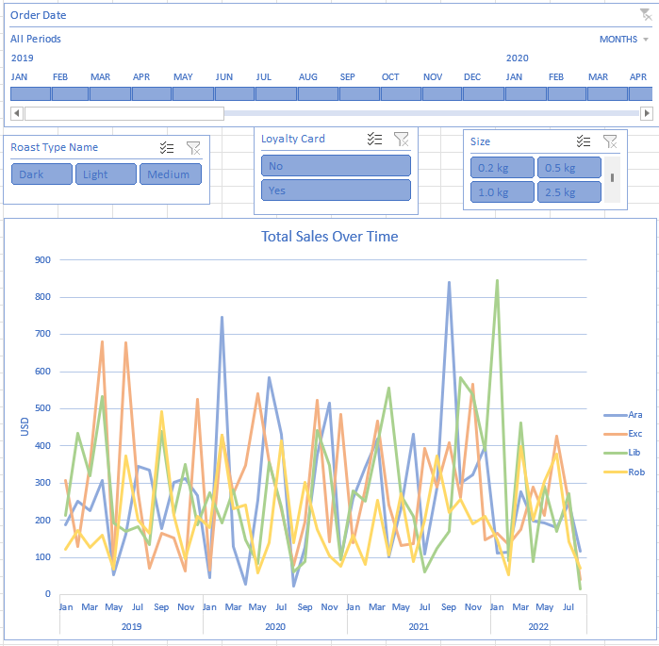 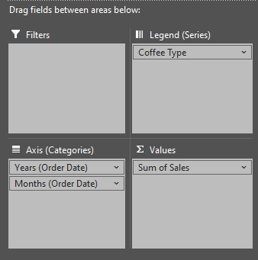

* To create our second pivot table, we will copy the total sales sheet everything is connected and change the name to Country. On the row values we will add the Country and on values Sales will remain. A bar char is inserted and formatted according to what we want.

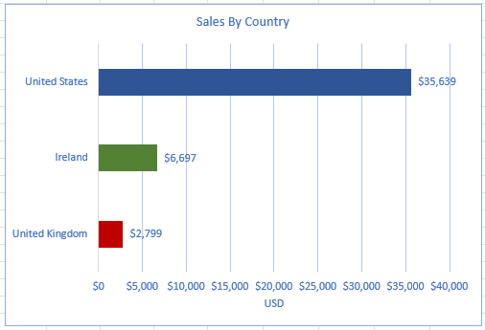 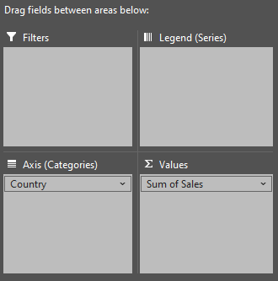

* Again, we will copy the country sheet and its content for the final pivot table. We are met with a very messy bar chart so filtering for the top 5 in ascending order is necessary.

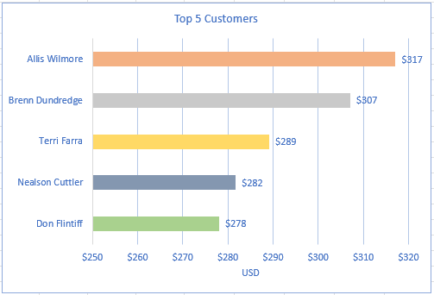

**Dashboard Creation**

For our final step we create a new sheet where our dashboard is going to be.

* For the A column we will adjust the width to 1 and the same for the row 1, where the height will be 5.
* Now we inserted a shape to define our dashboard and add a title.
* Here we will cut and paste all our charts in our dashboard and arrange them as we see fit. As a little note use ALT and drag the carts to adjust them.
* To make it cleaner we will hide the gridlines, formula bar and headlines.
* Lastly, we click on the slicers, go to the timeline tab, and report the connections to connect all our charts.

Note. You can also disable the scroll bars, sheet tabs and more.

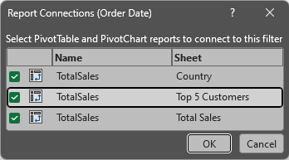

Step 4. Data Visualization

**Business Queries**

1. Who was our top customer in 2022?

Our top customer in 2022 was Teddi Crowthe according to our data, with a total of $205 spent in our company.

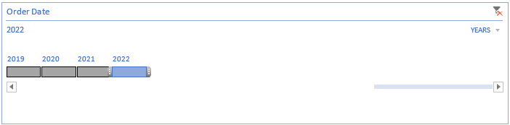

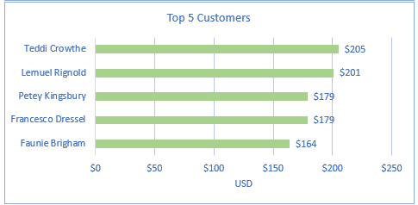

We got to this conclusion through the total sum of sales for each customer.

1. Which country buys coffee the most?

The country with most sales is United States.

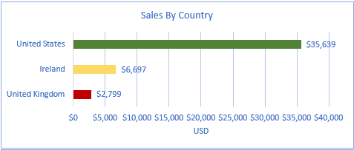

We got to this numbers through the total sum of sales for each country.

1. Which was our top product in September 2021?

Arabica was our top product on sales in September 2021 as shown below.

This result is obtained by summing the total sales by coffee type.

1. Who are our top 5 customers with loyalty card?

The top company customers with loyalty card are Brenn Dundredge, Brice Romera, Ailey Brash, Lacee Tanti and Elysee Sketch through all the period available on the data.

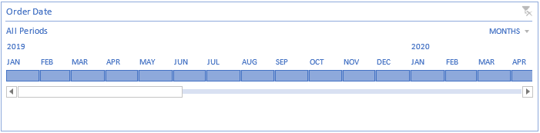

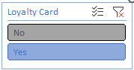

We got to this conclusion through the total sum of sales for each customer.

1. Which was our best month selling the light roast type for Excelsa?

Our top month selling the light roast type coffee was in April of 2019 with a total of $499.90.

This result is obtained by summing the total sales by light roast type through all the period available on the data.

1. When was our 0.5 kg products selling the most for Arabica?

The 0.5 kg products were selling the most in June 2022 with a total of $128.13.

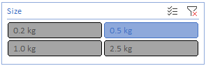

This result is obtained by summing the total sales by 0.5 kg products through all the period available on the data.

## Findings

Note. All the information below can be obtained drilling down the pivot tables, so it creates a new sheet with the data needed.

1. According to our previous analysis we were able to identify our top customer as Teddi Crowthe from the United States with an order of Excelsa Light x6 for $204.93.



1. The country where we sell the most products is the United States with 774 orders in total.



1. In September 2021 our top product was Arabica with a total of $840.93 in sales and 14 orders.



1. Our five best customers in the following order with loyalty card are:

* Brenn Dundredge, $307 spent and 7 orders.

* Brice Romera, $246 spent and 2 orders.



* Ailey Brash, $207 spent, and 4 orders.



* Lacee Tanti, $205 spent and 1 order.



* Elysee Sketch, $205 spent and 1 order.



1. April of 2019 was our best month selling the light roast type Excelsa coffee with $571.72 on sales and a total of 6 orders.

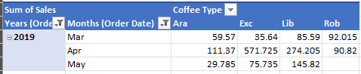

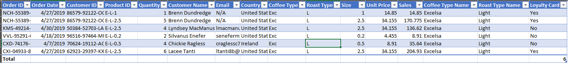

1. The 0.5 kg products selling the most for Arabica happened in June 2022 with a total of $128.13 with 4 orders.

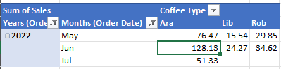



## Recommendations

I would advise to:

* Company should focus its sales on the United States since most of our sales and customers are from here. Also, is important to notice that our top customers are from the same country. As a personal recommendation I would advise to focus on a marketing campaign through social media, direct mail, brand development, affiliate marketing and user generated content to promote our products and brand.
* Is important to notice that the queries in question were not very valuable for insights and business needs, so a meeting with stakeholders and domain savvy collaborator should be made to stablish a better plan of action and generate better business queries.
* Data is lacking some important KPI’s that can provide a better understanding of how things go, a meeting between collaborators, data analyst, data engineers and decision-makers should be done to defined said KPI’s and how to capture this information.

## Conclusion

To conclude this report, I highly recommend acting on a marketing campaign based in the result of our findings, since is clear the best market is located in the United States based on sales and number of customers.

Is also important to notice that the business questions and KPI’s in the projects are lacking so further improvement is necessary for a future business strategy, objectives and goals.

Following these steps will bring a significant improvement in operation and profit in our company, so I urge all collaborators to act.

## References

* **Sources:**

<https://blog.hubspot.com/marketing/marketing-campaigns>

<https://use.expensify.com/resource-center/guides/analytic-reports>

<https://github.com/mochen862/excel-project-coffee-sales>

<https://coffeeparadiso.com/coffee-facts/>

* **Tools:** Excel.
* **Acknowledgments:** To Mo Chen on his guided excel project.